Quick Reference
PC Hardware Troubleshooting
Many end-users and support professionals alike look for software configuration issues first and don’t consider the possibility of a hardware failure. You should almost always start with the physical (hardware) layer and work your way up the OSI model when troubleshooting PC problems.
Beware of electrostatic discharge (ESD)
When working with PC hardware, ESD is always a hazard as it can damage electronic components. Equipment that has suffered ESD damage may continue to function, but will have a significantly reduced life span. To prevent electrostatic discharges, you should:
- Avoid placing cards near sources of static charges or magnetic fields, such as monitors.
- Use a grounding mat on your workbench.
- Wear a grounding wrist strap—except when working on a monitor or the inner workings of a power supply.
- Don’t touch equipment if either you or it has just come from a cold, low-humidity environment.
- Leave component cards in their static-free bags until you need them.
- Handle component cards by their edges, avoiding the contacts.
MOTHERBOARDS
Although different motherboard designs abound, all ATX form factor motherboards have common components that you should recognize. Figure A shows two ATX form factor motherboards. Although the boards are configured for different CPU types, they do have many similar features. The expansion slots are located on the end of the board opposite the CPU. The I/O ports are stacked behind the CPU, and the memory slots are in front of the CPU.
Figure A: Slot 1 and Socket 370 ATX motherboards
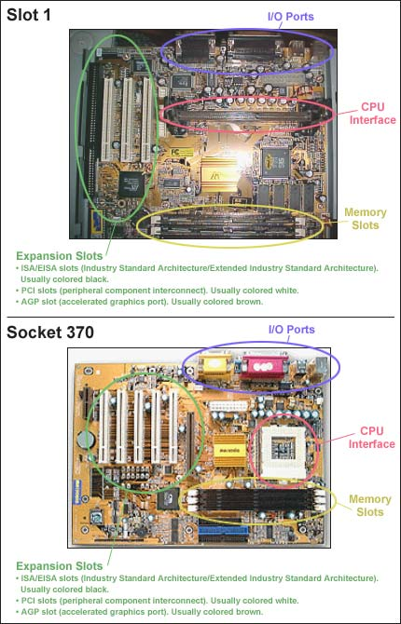
RAM CHIPS
Faulty or incompatible RAM chips can cause a variety of problems such as random system lockups, application installation failures, and even boot errors. Unfortunately, troubleshooting RAM chips is often a process of trial an error. Once you’ve eliminated all other possibilities, it’s time to check for an actual memory problem.
- The screen is blank: Check that the VGA card and memory chips are seated properly. Ensure the RAM chips are compatible with the motherboard.
- Not all memory is counted: This often means incompatible RAM chips have been installed. On many machines, chips are installed in pairs. If a new pair is not counted, check for compatibility with the motherboard and/or the existing chips. Error checking and correction (ECC) chips also have the habit of gradually counting less and less when there are problems.
- Computer hangs or suddenly reboots: Check that there is sufficient memory. Check for possible corrosion between each socket and chip. A faulty power supply can also be the culprit.
- General-protection faults: This is often caused by two pieces of software trying to occupy the same memory address. Rebooting usually solves the problem. If the problem occurs immediately after installing new memory, replace the chips. If the problem does not reappear, check with the manufacturer of the problem chips for known difficulties. You can often fix this problem by making sure that all the chips belong to the same batch from the same manufacturer.
- Memory errors reported by computer: If you get a “memory mismatch” error, make sure that settings are correct in CMOS (complementary metal-oxide semiconductor). Other errors such as “memory parity interrupt…,” “memory address error…,” “memory failure…,” and “memory verification error…” tend to occur when written information is not read back correctly from memory. The best way to check for incompatible chips is to remove the new chips and see if the problem goes away. If it does, your old and new chips may be incompatible. Install all new chips to solve the problem.
- Memory errors reported by memory system managers: System managers monitor and report component abnormalities. Unless you are using ECC chips that automatically correct soft errors, a system manager will report a memory error if the rate of soft errors is greater than acceptable levels. I take this problem very seriously, as it can lead to server failure. Replace all the chips as soon as possible. Also make sure you have the latest BIOS.
HARD DRIVES
An important clue that a hard drive problem stems form a hardware issue is that all the drive letters associated with a particular physical disk are missing. This is because most hardware problems will cause the entire disk not to be recognized by the BIOS, so the operating system is completely unaware that the disk is there.
- Check the hard drive's cables. A wide range of cable problems can cause entire disks (and their associated drive letters) to disappear, including the following:
  - Cable detached from hard disk or motherboard: ATX motherboards normally have two IDE drive controllers with either 39 or 40 pins, as shown in Figure D. Reseating the cable connections should always be your first step when troubleshooting missing drives. You won’t often see the cable completely detached from the motherboard or drive, but it may come loose over time due to subtle vibrations within the computer caused by a process known as socket creep.
Figure D: ATX motherboard IDE controller jacks
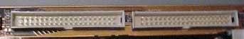
  - Cable wires bent or broken: Older cables can also wear out with age. In machines where cables were tied up tightly for several years, the tight bends in the cables led to slight breaks in the cable wires. You can often tell if this type of subtle destruction of the cable is taking place because the disk will act erratically for a while before it completely disappears. There will be no obvious external signs that the cable is bad, so the only way to test for this problem is to swap out the old cable with a new one.
  - Cable reversed at motherboard or drive: Another common reason that a drive won't show up is when its cable is put on backwards. Always make sure that the red stripe (indicating Pin 1) on the cable is closest to the power supply. You may need a flashlight and/or magnifying glass to discover the marking on the motherboard connector that indicates which end is Pin 1.
  - Wrong cable type: The wrong cable type can also cause drive recognition problems. Newer UDMA 66+ drives require UDMA 66+ cables, so if you use a cable designed for older drives, your UDMA 66+ drives may not appear to the system.
- Check the hard drive's jumper settings. New hard drives are typically set to make the drive a master. If the jumper settings are not changed and you add the drive to an IDE cable that already has a drive set as master, the drive may not appear to the BIOS (and thus it is missing when you boot up). It's also possible for incorrect jumper settings to cause a drive to be recognized only intermittently at boot up.
You should also avoid the Cable Select jumper setting. When both drives are set for Cable Select, the position of the drive on the IDE cable determines the master/slave relationship of the drives. If you choose the Cable Select option, make sure that both drives are configured for Cable Select. Be aware that some hard drives do not work with this option, and cable problems sometime prevent the Cable Select option from working correctly. In general, you should manually configure your drives as either master or slave.
- Check the SCSI settings. Some SCSI specifications support an auto-detect and configuration feature that automatically sets the SCSI ID settings on drives in a SCSI chain. The SCSI ID is a drive identifier that notes the unique position of each drive in a SCSI chain in the same way that the master/slave setting on IDE drives determines the positions of the drives on an IDE cable. If your SCSI drives and controller do not support the auto-configuration feature (supported by some SCSI III implementations), you must manually set the SCSI ID on each drive.
Check the ID setting on each drive on the chain. The method of setting the ID varies with the drive and controller type. After confirming that the drive’s IDs are set correctly, check for SCSI chain termination. The controller should be self-terminating, but the last device on the chain must be manually terminated. SCSI drives typically ship with a terminator already placed on the drive. Make sure that only the last drive on the chain has the terminator in position.
FLOPPY DRIVES
- Check the disk. When a floppy disk suddenly begins experiencing problems, the disk itself should be at the top of your list of suspects. Compared to other forms of media, floppy disks are especially frail. They can be ruined by anything ranging from dust to magnetic interference. Test the disk in another computer. If neither computer can read a particular disk, then the disk is the problem. If one computer can read the disk, but another can’t, then the problem is obviously the floppy drive.
- Check the cables. As with hard drives and CD-ROM, CD-R/RW, and DVD drives, make sure the power cable is securely connected to both the drive and power supply and that the data cable is also securely connected to the drive and drive controller. Most modern ATX motherboards have one floppy drive controller with a 34-pin male jack, as shown in Figure E. Also ensure that the data cables are not reverse on the drive or the motherboard and the cable wires are not bent or broken.
Figure E: ATX motherboard floppy drive controller jack
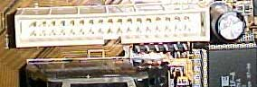
- Check for problems hidden by the operating system. Sometimes the operating system will mask a hardware floppy problem. For example, you write a file to a floppy disk and view the disk’s directory to verify that the file exists. When you try to access the file from another machine the disk is blank. You copy the file from the original machine to the disk again, this time opening the file from the floppy disk to verify its existence. When you try to open the file on another machine again the disk is blank. This scenario can occur when a floppy drive's write head malfunctions, but the operating system thinks the file was written. When you try to open the file to verify its existence on the original machine the operating system is actually reading the file from its disk cache rather than from the floppy.
The easiest way to diagnose a problem like this is to write the data to the disk and then eject and reinsert the disk. This will clear the floppy drive's disk cache and force the operating system to actually read data from the disk.
CD-ROM, CD-R/RW, AND DVD DRIVES
- Look at and listen to the drive. If the drive's light is not working, the door fails to open, and you don't hear any noise from the drive when a disc is inserted, the drive may not be getting power or may be damaged. If the light works and the door opens, but you don't hear the disk spinning, a physical obstruction may be preventing the disc from spinning or the drive may be damaged. The laptop CD-ROM drive shown in Figure F failed to function due to a tiny warning label that had been peeled back inside the drive. It had come loose at one of the corners, probably due to the heat, and was physically impeding the disc from spinning correctly.

Figure F: Unstuck label prevents laptop CD-ROM drive from spinning disc properly
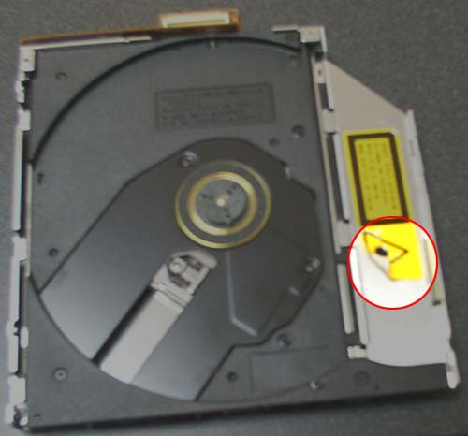

- Check the cables. As with hard drives and floppy drives, make sure the power cable is securely connected to both the drive and power supply and that the data cable is also securely connected to the drive and drive controller. If you're having sound problems make sure the audio cable is securely connected to the drive and the motherboard or sound card. Also ensure that the data cables are not reverse on the drive or the motherboard and the cable wires are not bent or broken.
- Check the drive's jumper settings. As with hard drives are typically set to make the drive a master. If the jumper settings are not changed and you add the disk to an IDE cable that already has a disk set as master, the disk may not appear to the BIOS (and thus it is missing when you boot up). It's also possible for incorrect jumper settings to cause a disk to be recognized only intermittently at boot up.
- Check the driver. Ensure that the correct driver for the operating system and drive is installed. Try removing and reinstalling the driver. As a general rule it is best to install the most recent driver, but it's not uncommon for brand new drivers to cause problems. In such cases, use the driver that works, even if it's not the most recent.
CD-R/RW burning speed problems
- Check the CD media. All CDs are rated for a specific burning speed. Some burning software performs an integrity test on the CD prior to initiating the burn sequence. This test determines the CD’s speed capacity and can limit the burning speed. If you try to burn a CD at a higher-than-rated speed, the burn will likely fail.
- Check the computer's available resources. Adequate system resources are essential for high-speed burns. If the resources are low, the buffer under-run protection may force the drive to record at a slower speed than desired. Windows 2000/XP systems should have at least 256 MB of RAM, while Windows 9x/Me users may be able to get away with 128 MB, but would do better with 256 MB. You should also defragment your hard disk prior to the burn and verify that you have at least 800 MB of free disk space.
- Check the CD-R/RW drive's installation. On some older systems, the slowest device on the IDE chain limits an IDE drive's speed. A 40X CD burner daisy chained to a 32X CD-ROM drive would be limited to 32X. If you have such a system, consider moving your burner to its own independent IDE controller. Even if your system doesn’t limit the speed to that of the lowest device on the IDE chain, it’s still advisable to have a different IDE controller servicing your CD burner than is servicing the hard disk that contains the data being copied to the CD. Using separate controllers for the hard disk and the burner allows each controller to dedicate the maximum amount of time to the respective device, resulting in higher data transfer rates and potentially higher burn speeds. If you don’t have the option of placing the hard disk and the burner on separate controllers, you might check with your system’s manufacturer for updated hard disk controller and system board drivers. Often these OEM drivers perform better than the Windows generic drivers.
- Check the Windows swap/paging file. A small, fixed-size swap/paging file can cause slow CD burn speeds. Verify that the Windows swap file is enabled and that the minimum size is at least 1.5 times the size of the system’s physical RAM. If possible move the swap file to a different physical hard disk—not just to a different partition—than the one containing Windows.
VIDEO CARDS
- Check the cables. Ensure that the monitor is powered on and snugly connected to the video card.
- Run Windows in Safe Mode. If this solves the problem it's likely the video driver is not working properly or the wrong video driver is installed.
- Check the video card driver. Ensure that the correct driver for the operating system and video card is installed. Try removing and reinstalling the video card driver. As a general rule it is best to install the most recent video card driver, but it's not uncommon for brand new drivers to cause problems. In such cases, use the driver that works even if it's not the most recent.
- Check the video card. Over time video cards can become unseated from the motherboard. Open the case and ensure that the card is snuggly connected to the motherboard.
- Replace the video card. If all else fails, replace the video card. If this solves the problem, the video card is likely broken. If possible, try the card in another computer to be sure the card is broken before discarding.
MONITORS
While monitors suffering from damaged phosphors, convergence problems, or uncorrectable screen distortion are generally not worth fixing, most monitor issues can be corrected if you know what troubleshooting tips to apply.
- Check the monitor's physical environment. Monitors are notoriously sensitive to magnetic fields. Speakers, florescent lights, fans, cell phones, radios, and any other electrical device can cause a wide range of monitor problems.
- Check the cables. Ensure that the monitor is powered on and snugly connected to the video card.
- Adjust the controls on the monitor front or back. Sometimes, picture problems, such as a black ring around the display or a tilted or pincushion appearance, can be fixed from there. Ensure the brightness and contrast are appropriately set.
- Try a different refresh rate. Sometimes, a too-high refresh rate can cause distortion or other problems. A too-low refresh rate will have users complaining about flickering, eyestrain, or overall poor-quality picture.
- Check the video card.
- Try a monitor-testing program. Some of these programs will take a monitor through several resolutions and color depths; others are simply test patterns and solid color screens that allow you can to visually check for display flaws.
- Display a pure white screen and look for convergence problems. This will appear as places on-screen with a red, green, or blue tint, and it indicates a problem with the dots in the triads not aligning properly. Some monitors have an adjustment to correct this. If you don’t have a utility that will give you a pure white screen, a shortcut is to open a new document in a word processing program and maximize the window. Also look for any individual pixels that are not white; this can indicate a damaged phosphor in that spot.
- If possible, display pure red, pure green, and pure blue screens and look for any dropped-out pixels. A monitor-testing program usually provides such screens.
SOUND CARDS
- Check the volume. Make sure that both the software and hardware volume controls are properly set.
- Check the speakers. Ensure that the speakers are powered on and securely connected to the correct sound card jack.
- Check the sound card driver. Ensure that the correct driver for the operating system and sound card is installed. Try removing and reinstalling the sound card driver. As a general rule it is best to install the most recent sound card driver, but it's not uncommon for brand new drivers to cause problems. In such cases, use the driver that works, even if it's not the most recent.
- Check for conflicts with onboard sound device. Sound cards can conflict with an onboard sound device. Check the motherboard manual or Windows Device Manager and see if the motherboard has onboard sound. If present, disable the onboard sound device in the BIOS.
- Check the cables. If you're having sound problems with a CD or DVD drive make sure the audio cable is securely connected to the drive and the motherboard or sound card.
- Check the card. Over time sound cards can become unseated from the motherboard. Open the case and ensure that the card is snuggly connected to the motherboard. Some motherboards pool interrupts for the PCI slots, which can cause conflicts. To resolve such conflicts, uninstall the sound card and then reinstall it in a different PCI slot.
- Replace the sound card. If all else fails, replace the sound card. If this solves the problem, the sound card is likely broken. If possible, try the card in another computer to be sure the card is broken before discarding.

Technical Editor: Bill Detwiler
Technical Contributors: James Detwiler, Brien Posey, Kyu Rhee, Debra Shinder, Faithe Wempen
Copy Editor:
Graphic Artist:

